NAME :M.NAVEEN KUMAR REDDY

REG.NO :192111719

COURSE :COMPUTER NETWORKS

CODE :CSA0719

FACULTY :DR.ANITHA.G

**LAB MANUAL 1 TO 5LL**

1.Configuration of Network Devices using Packet Tracer (Hub, Switch, Ethernet, Broadcast)

**HUB:**

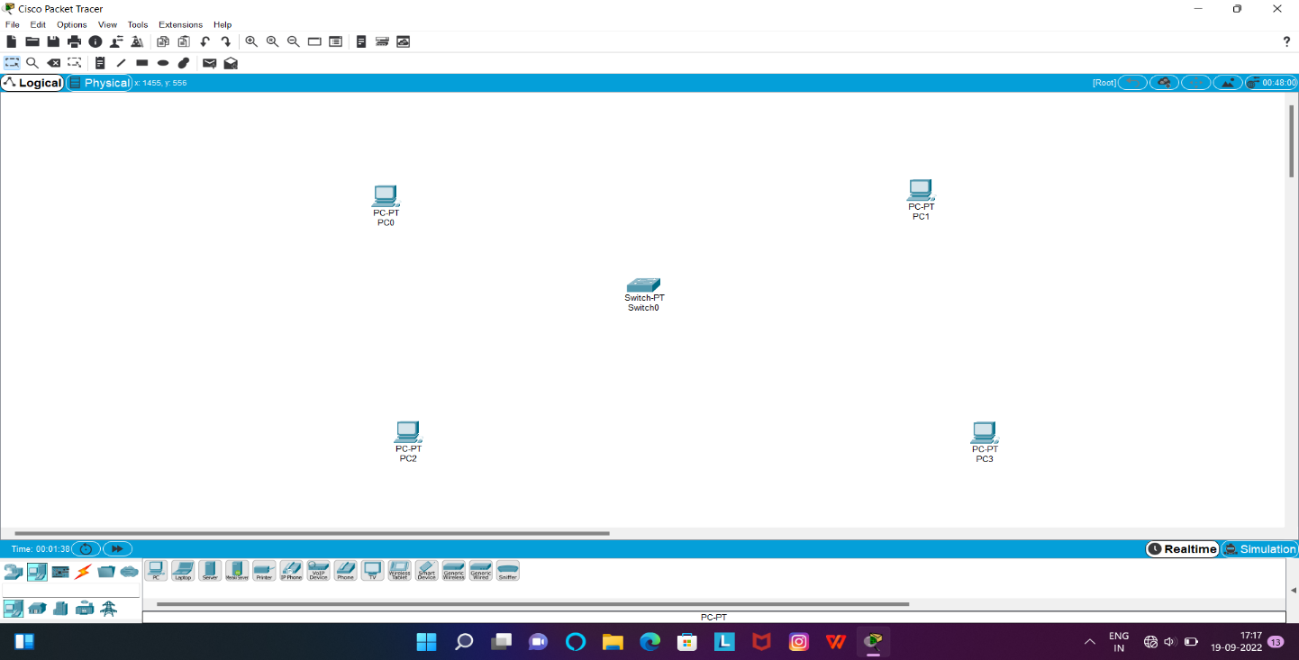

**SWITCH:**

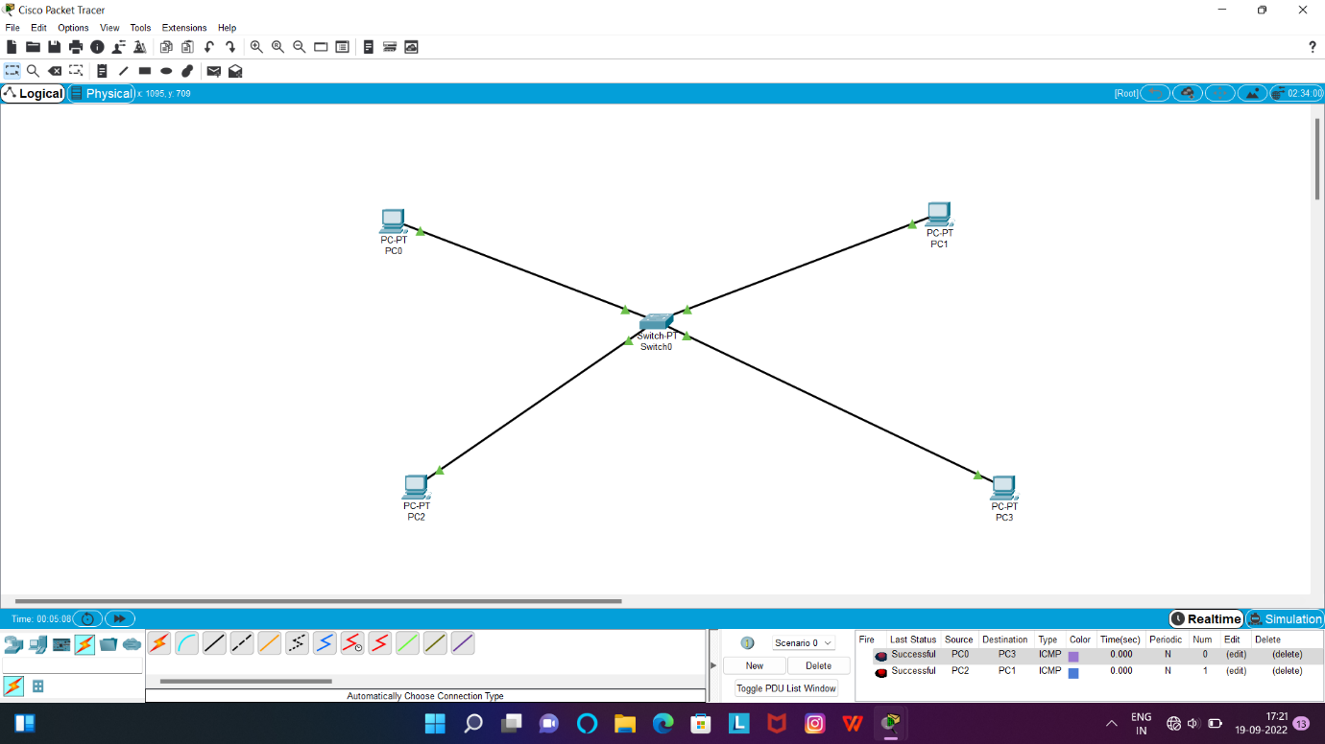

**ETHERNET:**

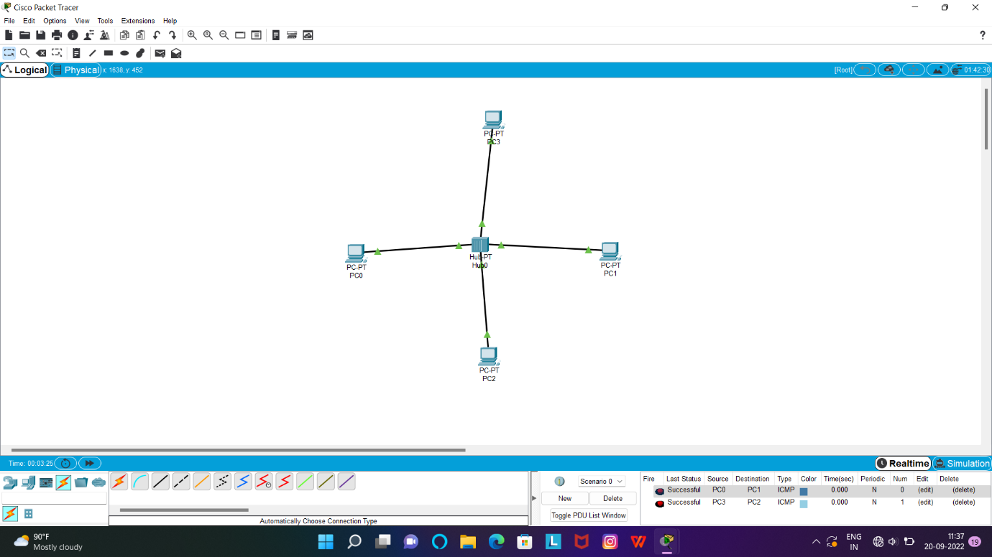

**BOARDCAST:**

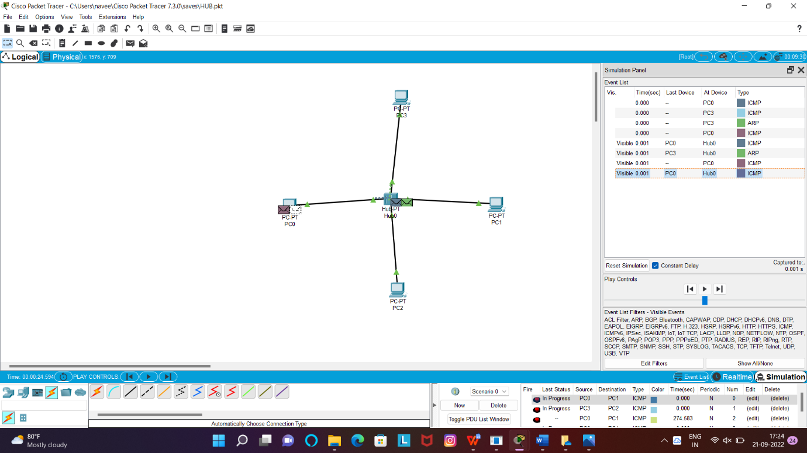

2.Configuration of Topologies using Packet Tracer (Star, Mesh, Tree,)

**TREE:**

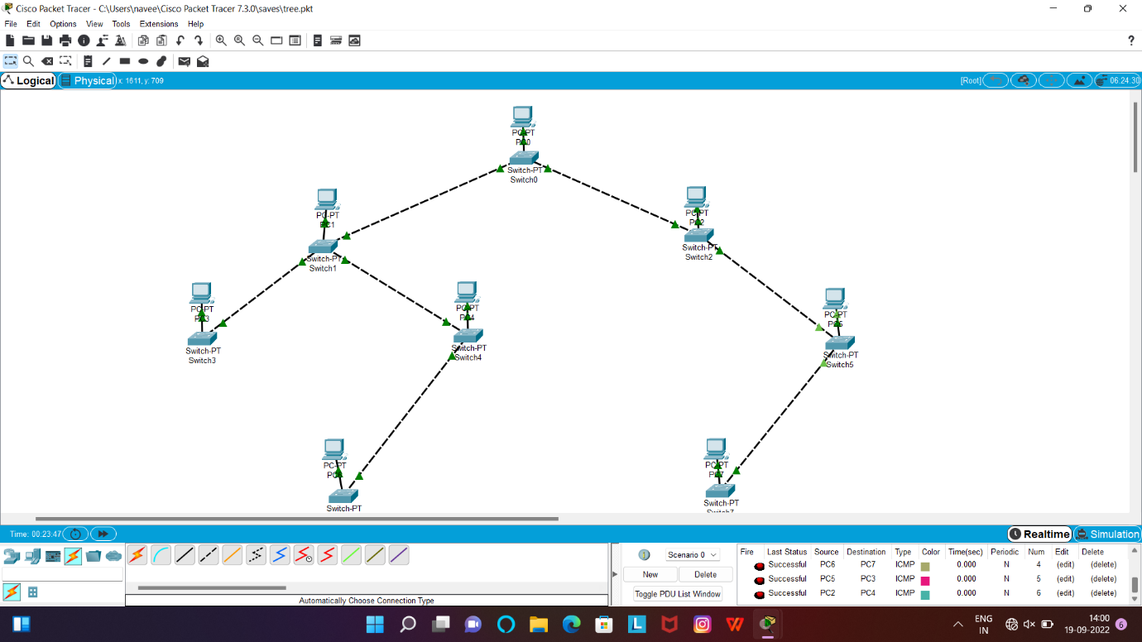

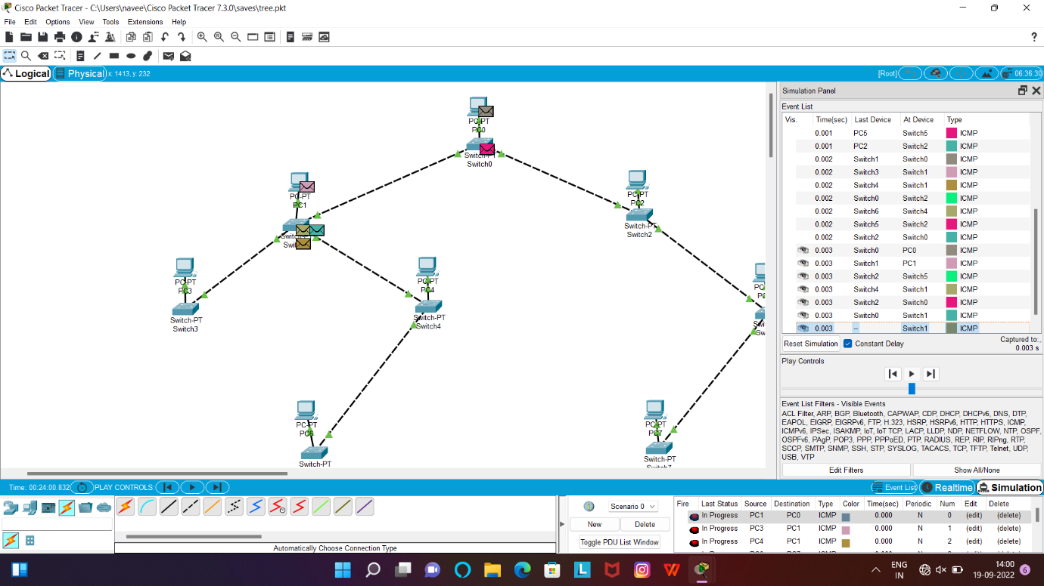

**MESH:**

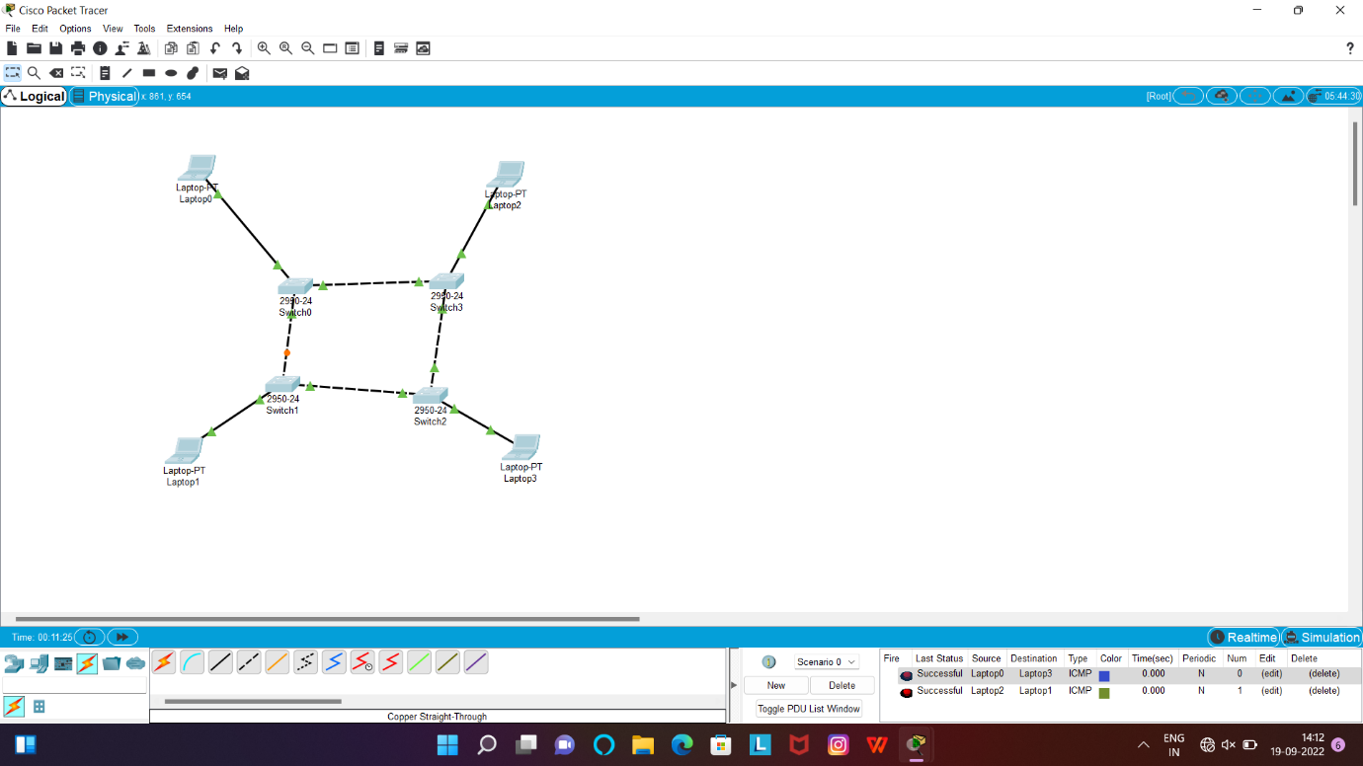

**STAR:**

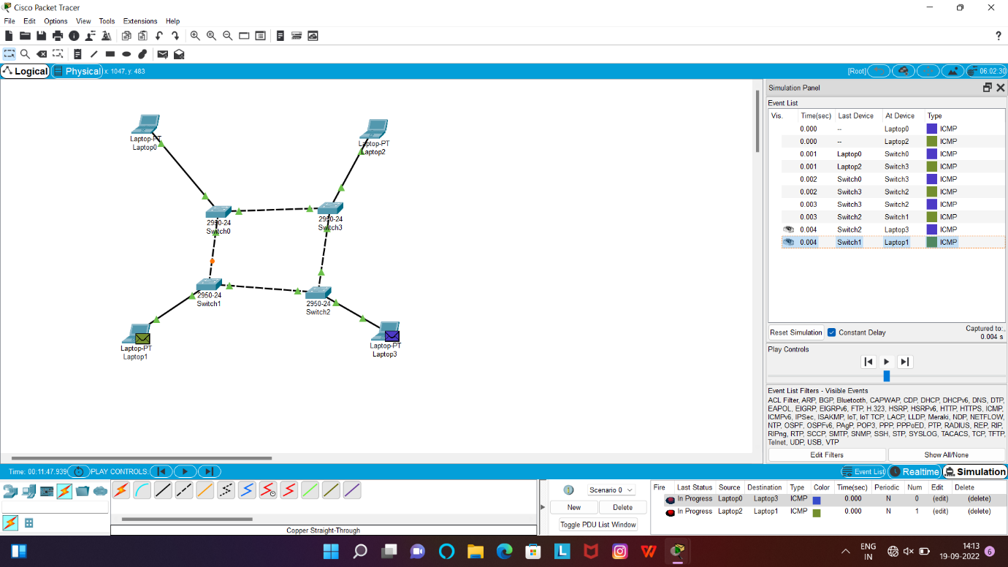

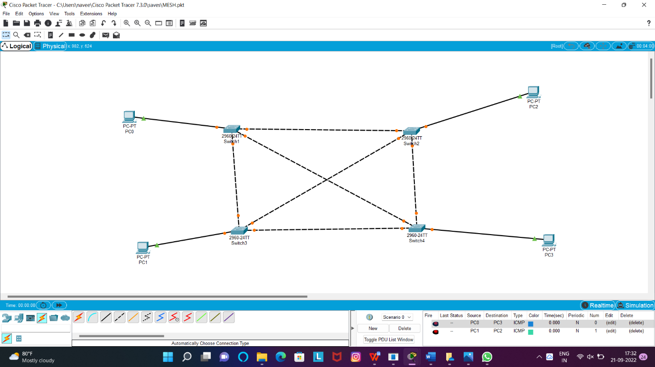

3.Configuration of Topologies using Packet Tracer (Bus, Ring, Hybrid)

BUS:

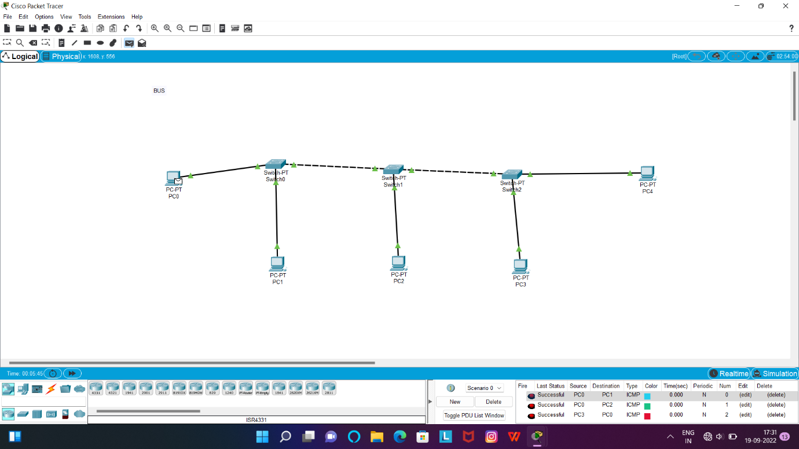

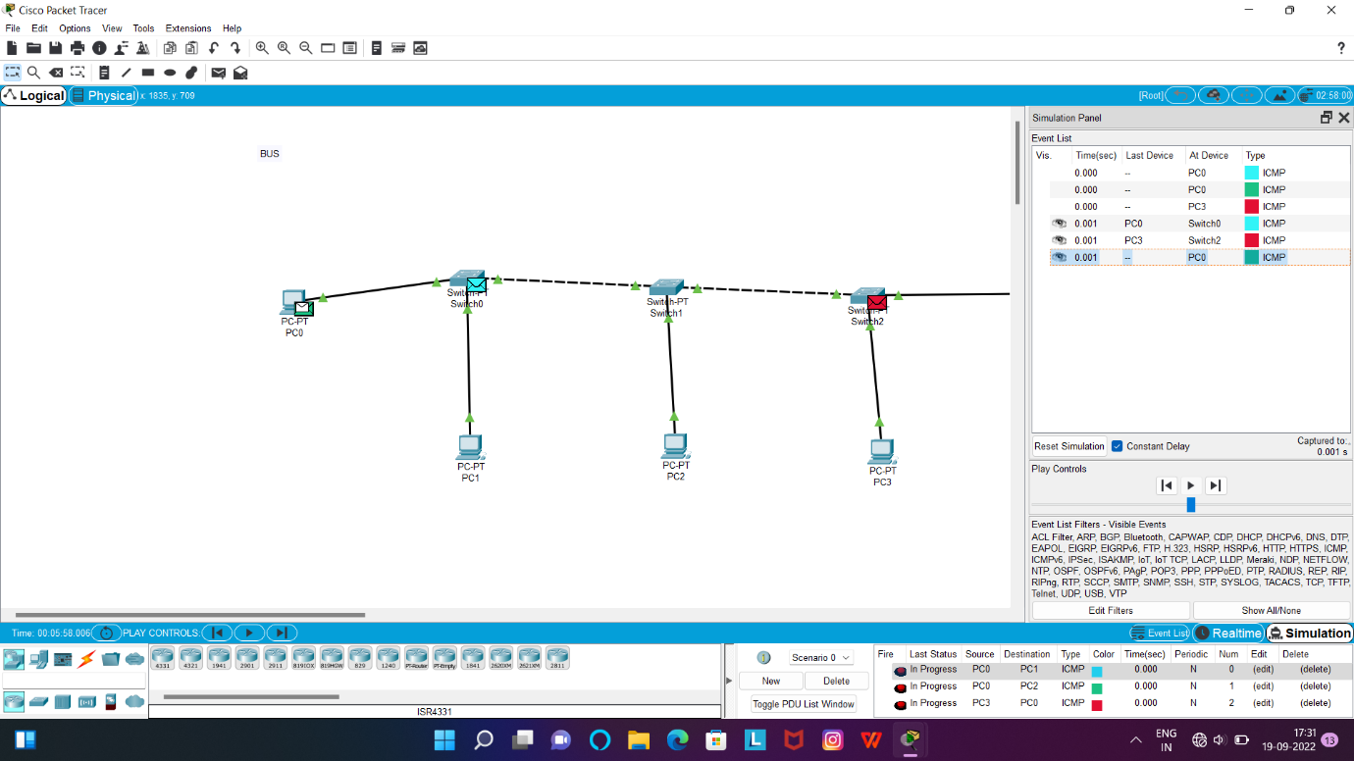

**HYBRID:**

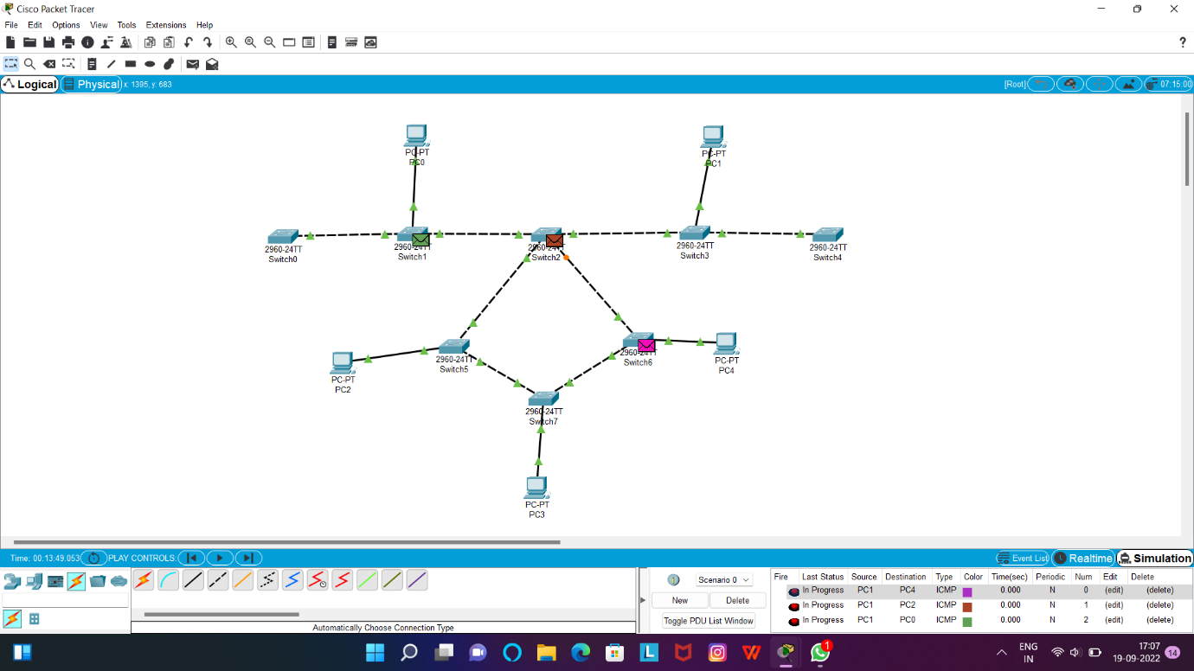

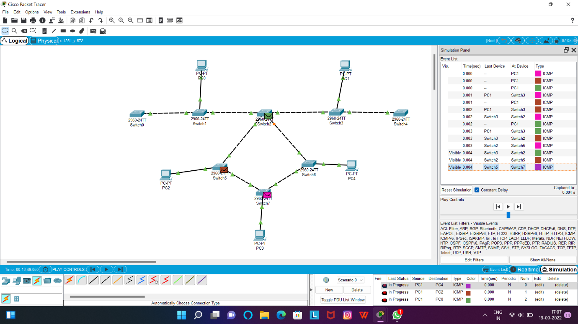

**RING:**

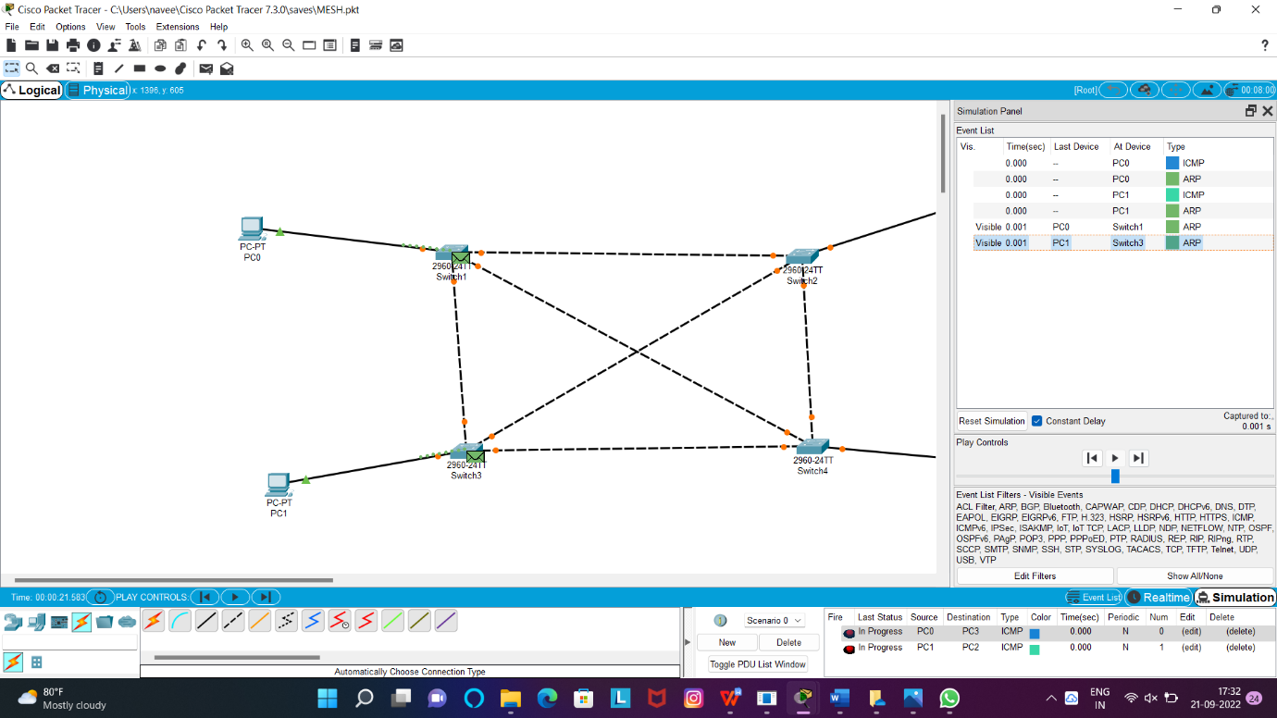

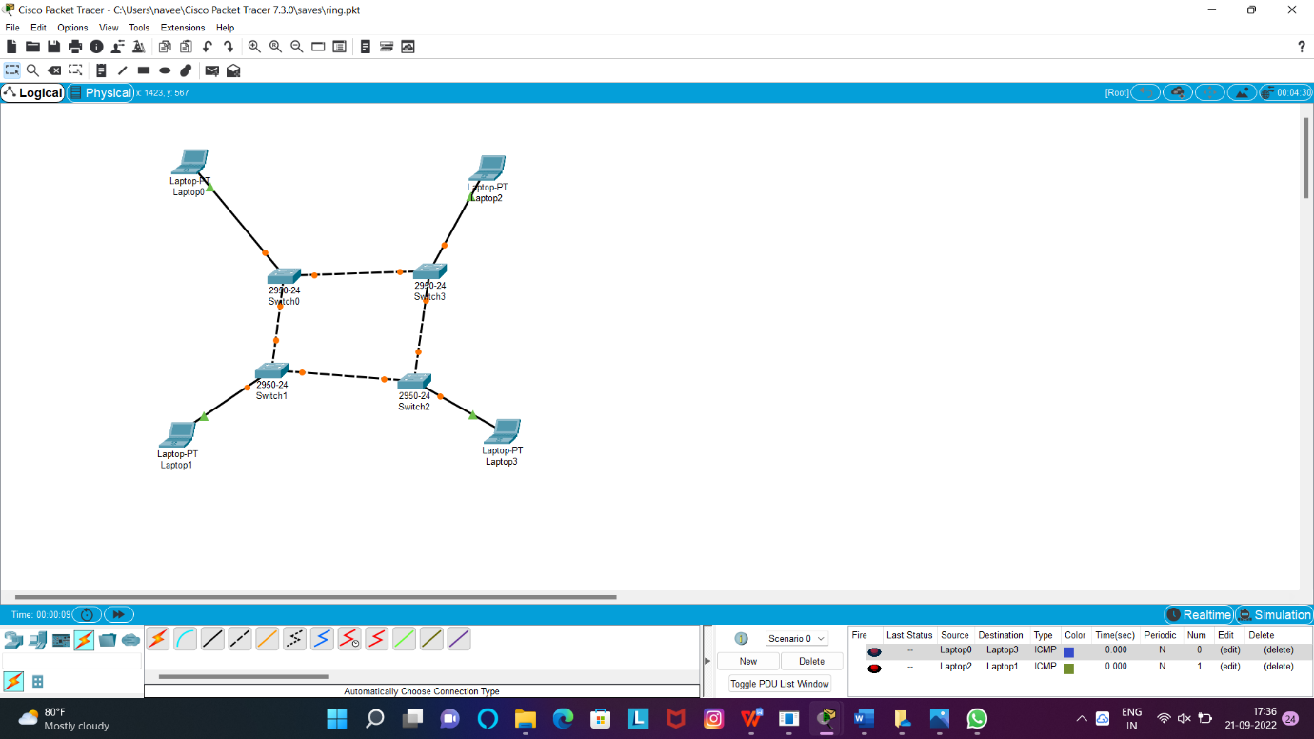

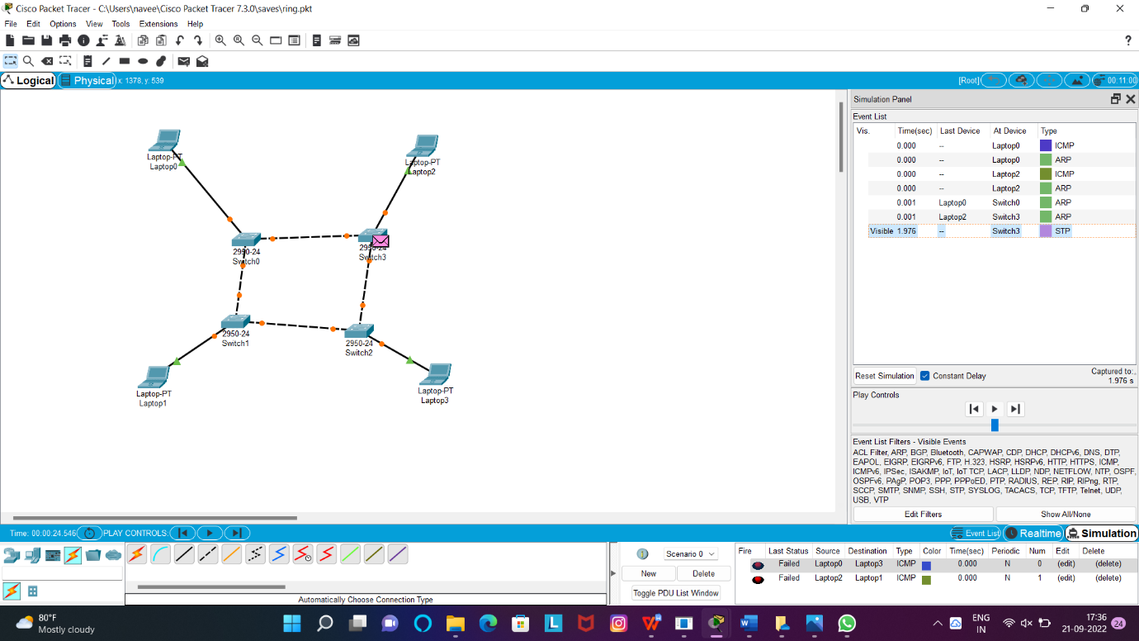

4.Data Link Layer Traffic Simulation using Packet Tracer Analysis of CSMA/CD& CSMA/CA

**CSMA/CD/CA:**

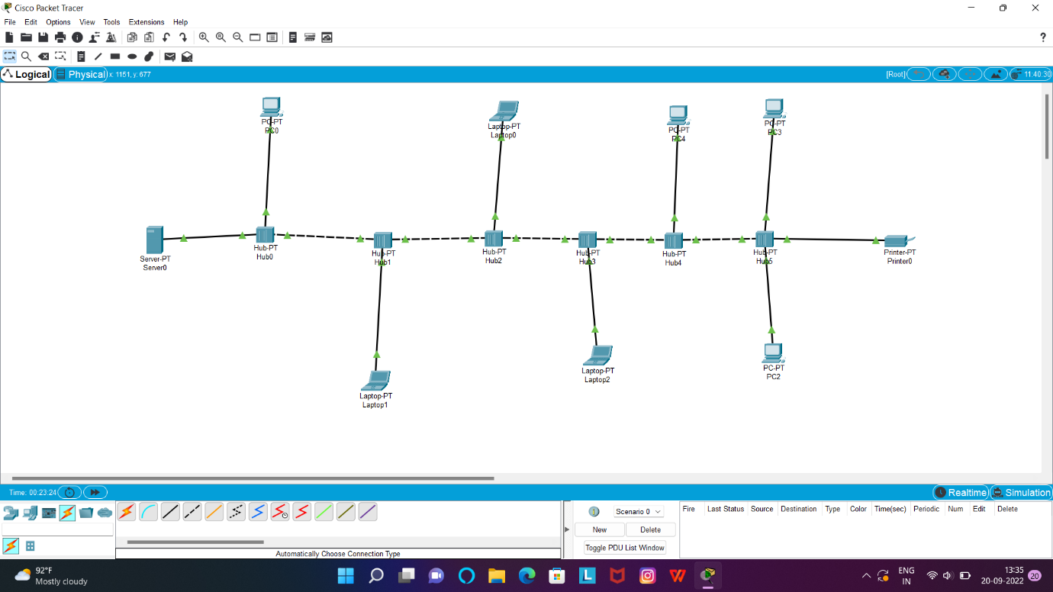

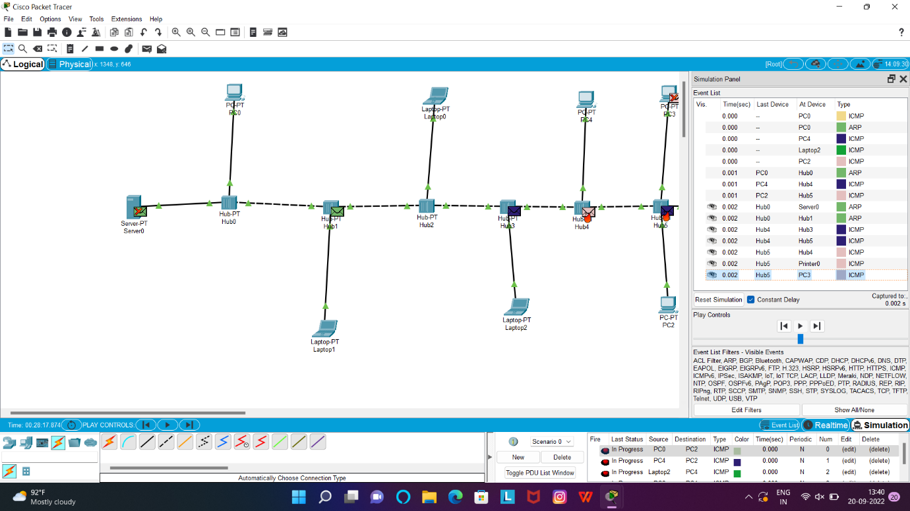

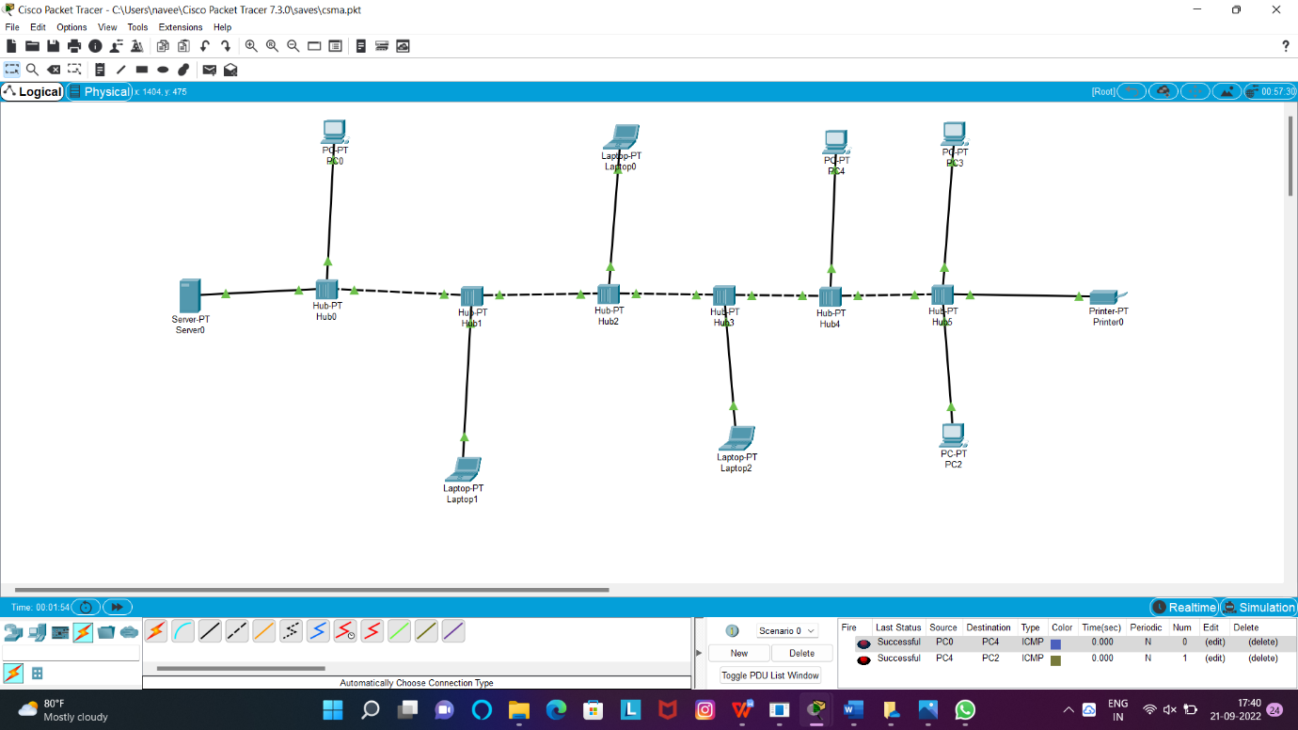

5.Data Link Layer Traffic Simulation using Packet Tracer Analysis of ARP

**ARP:**

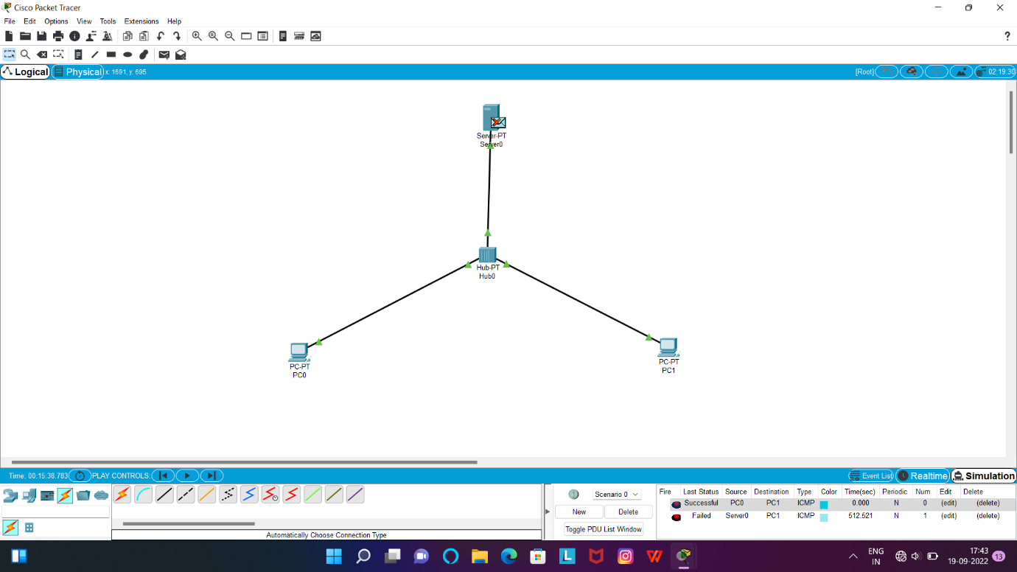

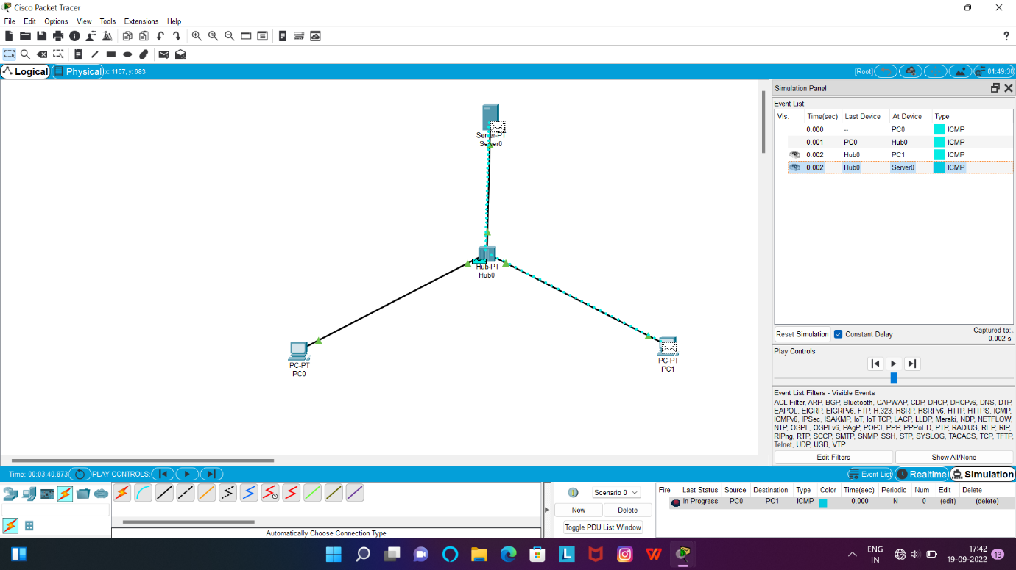

**LLDP:**

